Emergency Procedure Reminders

On the back of every classroom door:

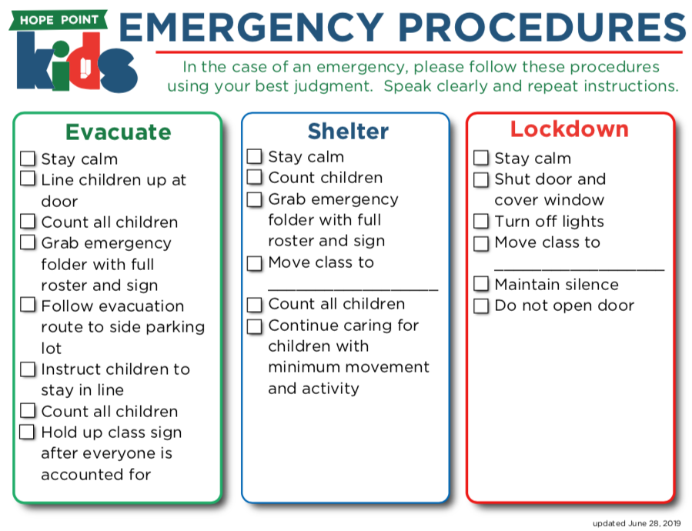

Folder & Class Rosters also on back of door
Includes:
- Class Rosters
- Fire Evacuation plan
- Sign (to hold up in an evacuation)
- Action Plans for any special needs

First Aid:
- Band-aids and simple supplies in cabinet
- First aid kit is located in the supply closet
- Medic bag is located in the lobby

Seizures
- Look at the clock (very important)
- Remove furniture that may be in their way
- (Unless action plan states otherwise) Send someone to get the officer on duty to call EMS.
- Remove other children from the classroom, for privacy of the patient.
- The officer will relay time information to EMS

Allergies
- Allergy information is reviewed annually with parents
- Allergy information should be listed on the name badge and on the roster.
- In general, we do not serve food or do food based activities in HPKids on Sunday Mornings
- Please familiarize yourself with the allergy concerns in your class

Special Needs
- Detailed Action Plans are created with the parents to give you as much information as needed while still protecting privacy of a child’s medical information.
- Please become familiar with the action plans for students in your class
- ALWAYS ASK FOR HELP as soon as you become uncomfortable with behaviors or needs of a child.

